Creation of a new Change Request bundling Payment Terms and Payment Term Details
https://id1r3.itego.de:53400/sap/bc/webdynpro/sap/usmd_crequest_create?sap-client=100&sap-language=EN&WDCONFIGURATIONID=USMD_CREQUEST_CREATE#

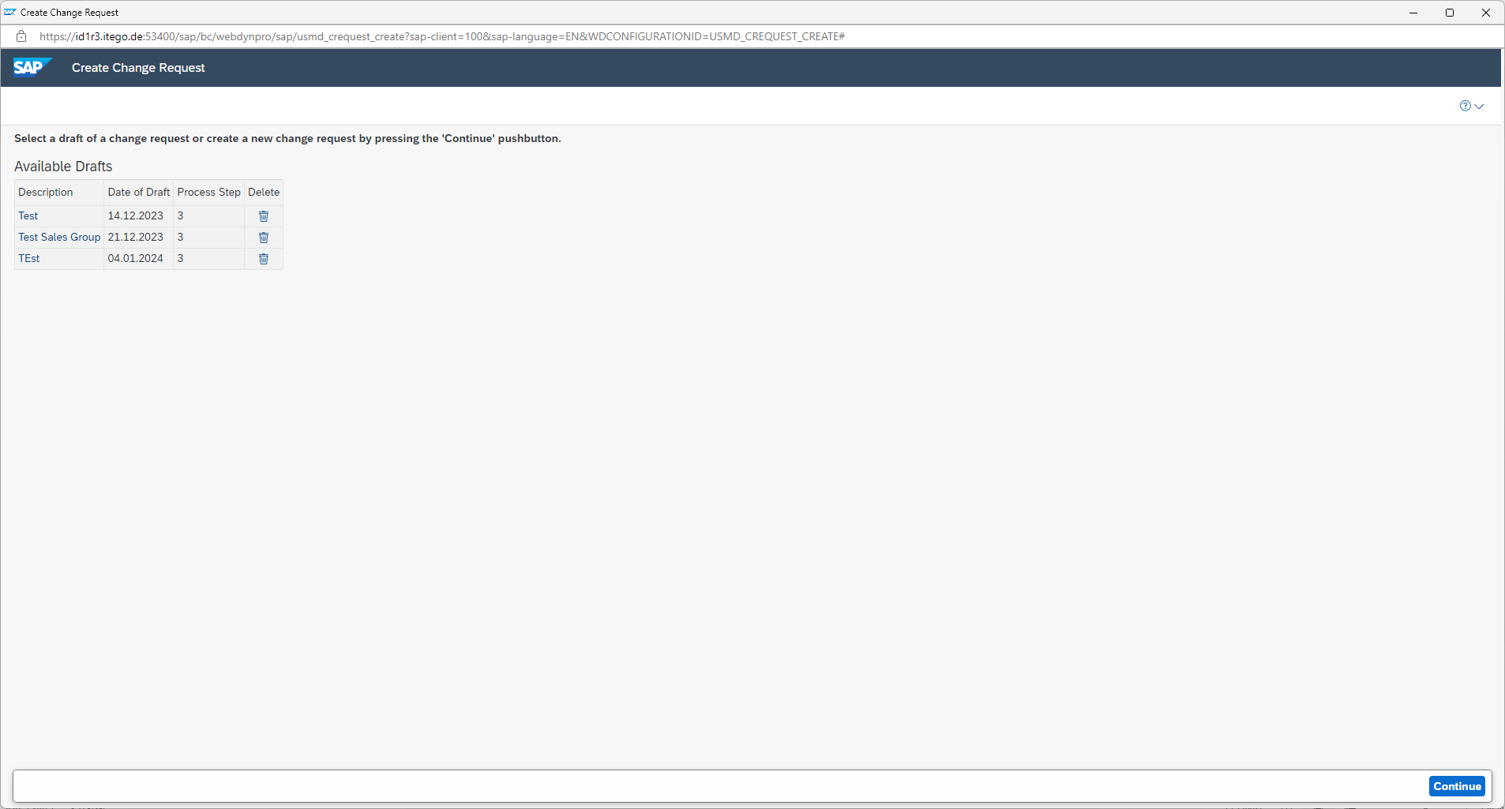
Enter description and select the type of change request that should be created. (The Change Request Type needs to be setup beforehand to make it available)
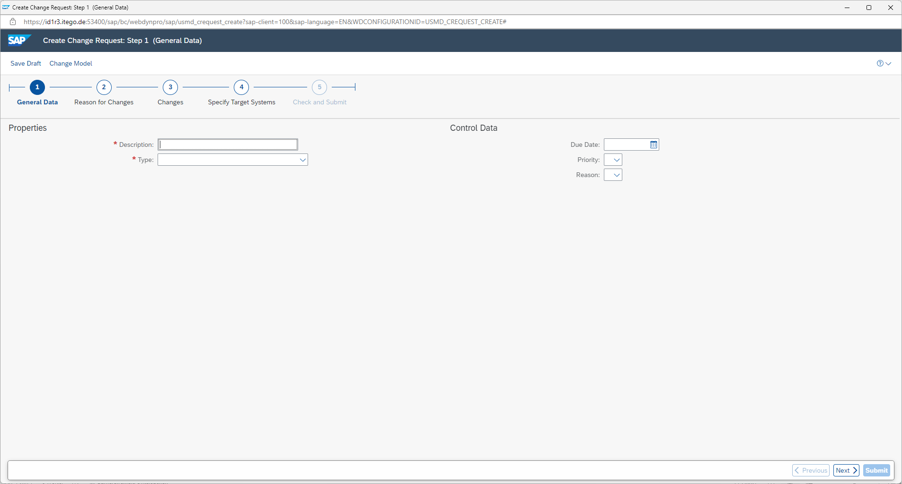
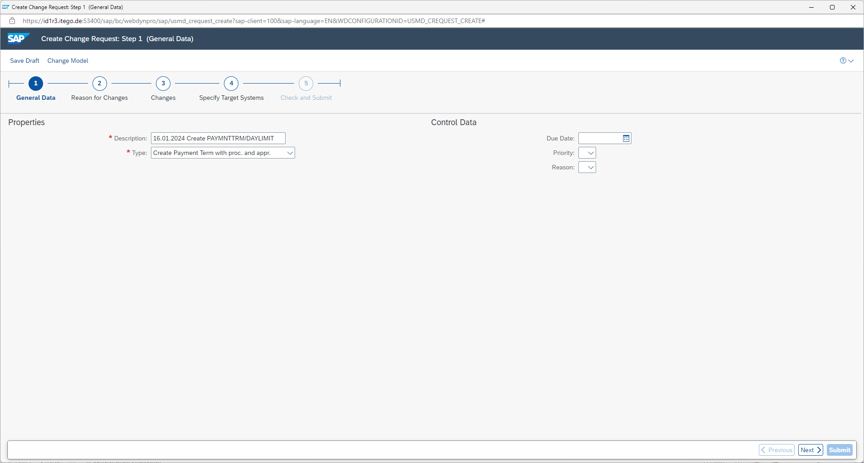
Maintain note for change request reason
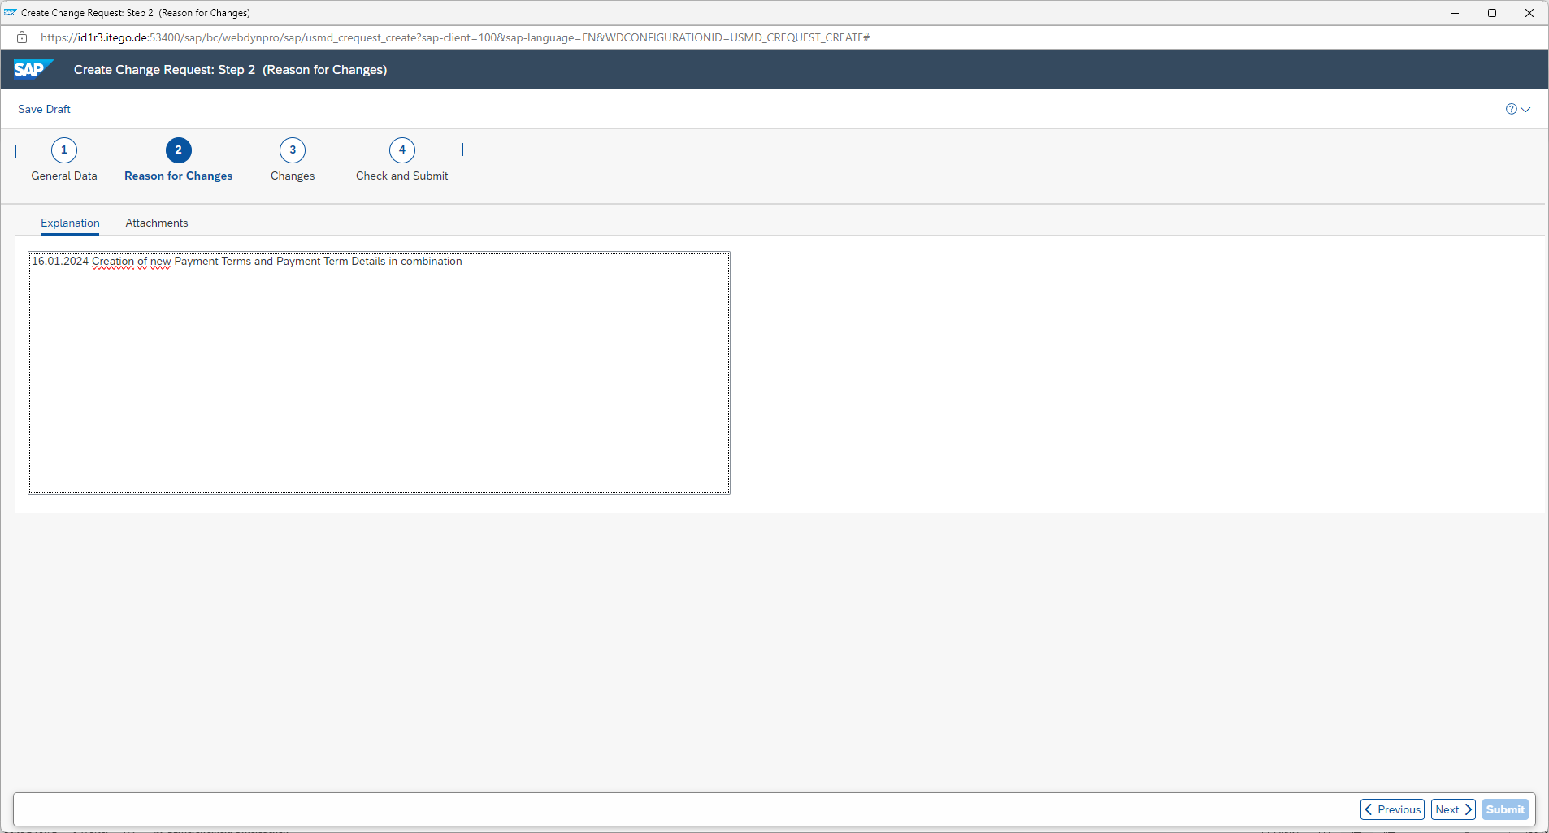

Select the Terms of Payment to maintain
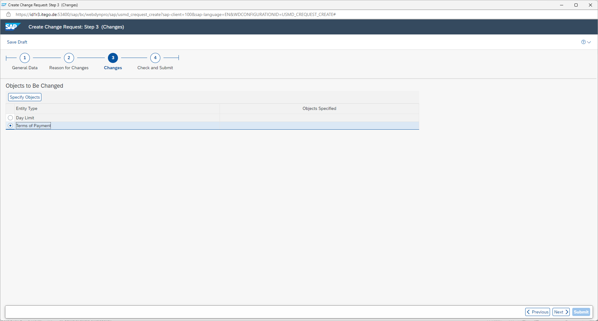
In this demonstration two new Payment Terms will be created (PT10 and PT11)
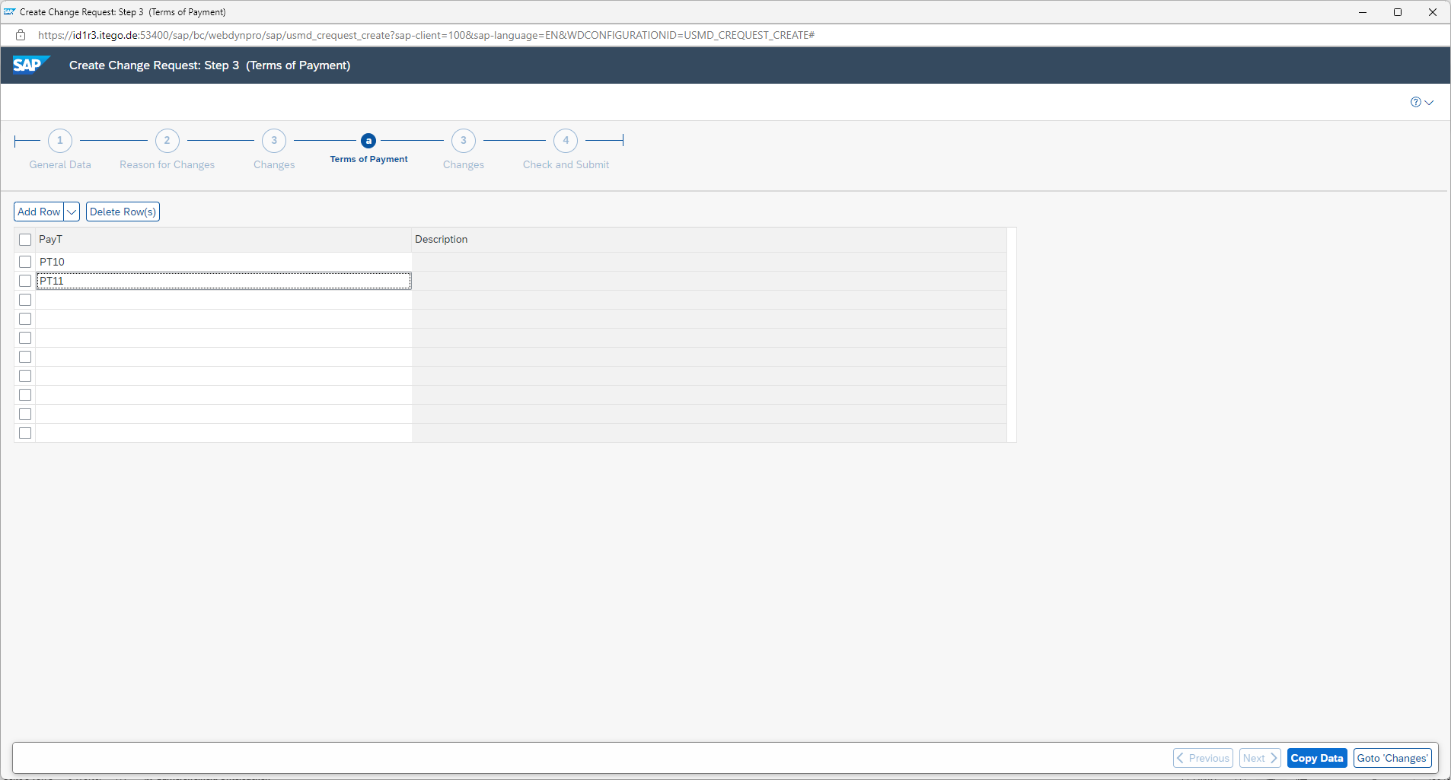
After a click on „Copy Data“ you will be send back to the previous screen

Select „Day Limit“ (Payment Term Details) to maintain
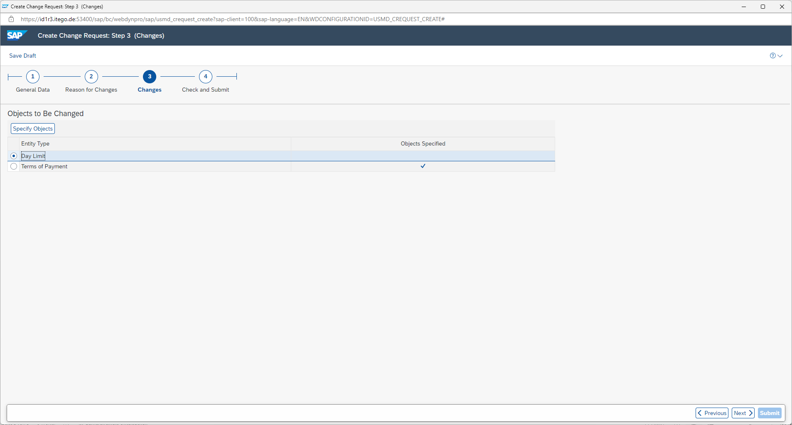
For this demonstration four new „Day Limits“ (Payment Term Details) will be created. Day Limit 95 and 96 for Payment Term PT10 and Day Limits 97 and 98 for Payment Term PT11
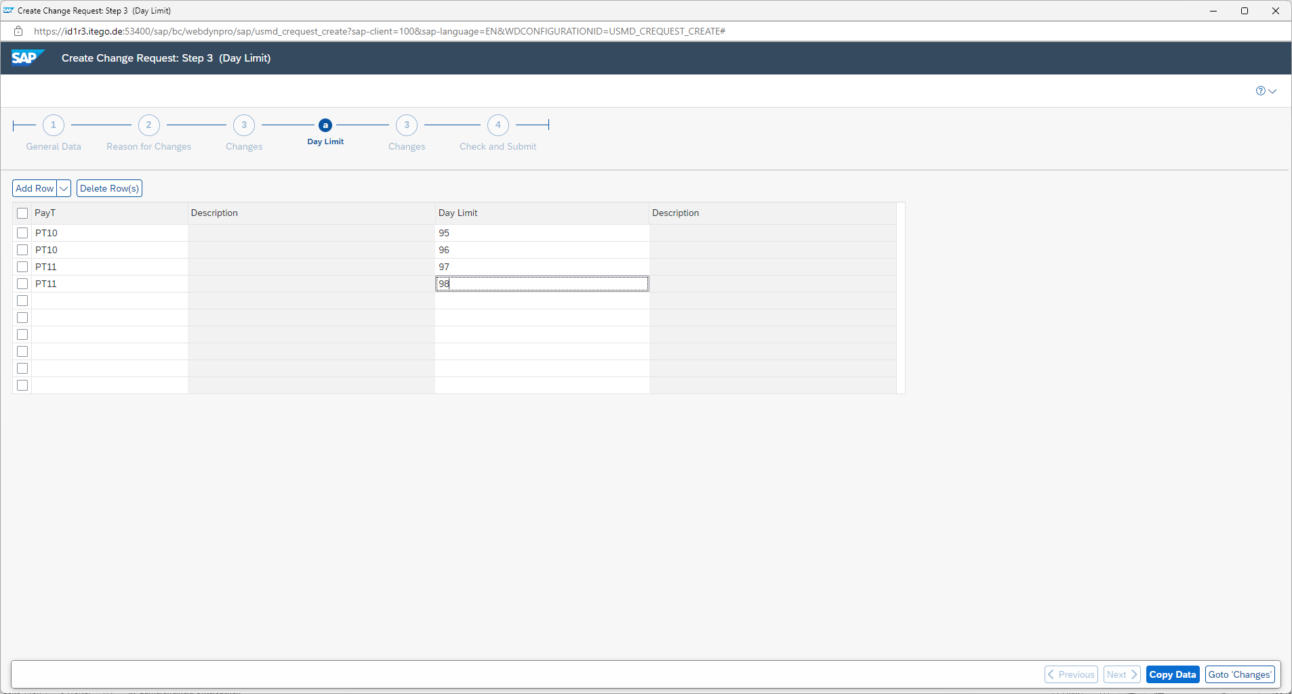
After a click on „Copy Data“ you will be send to the previous screen
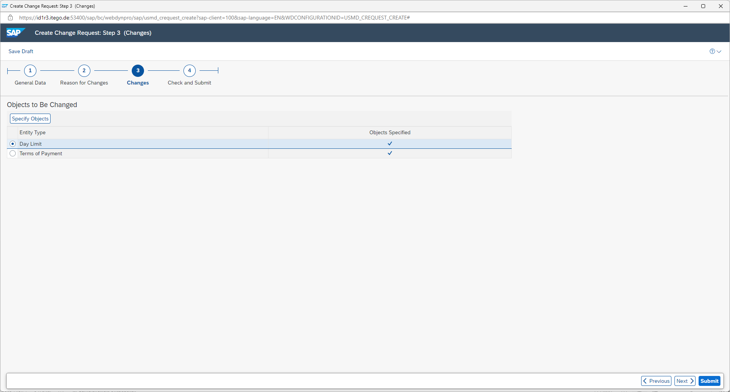
By clicking on „Next“ you will get to the final „Check and Submit“ segment
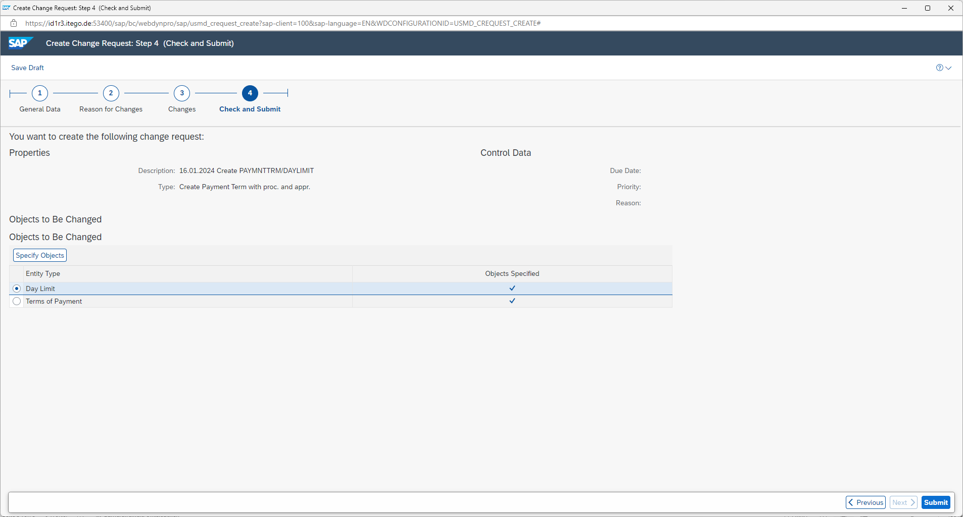
Click on „Submit“ to finalize the creation of the change request

The change request has been successfully created and will be view- and changeable via „My Change Requests“
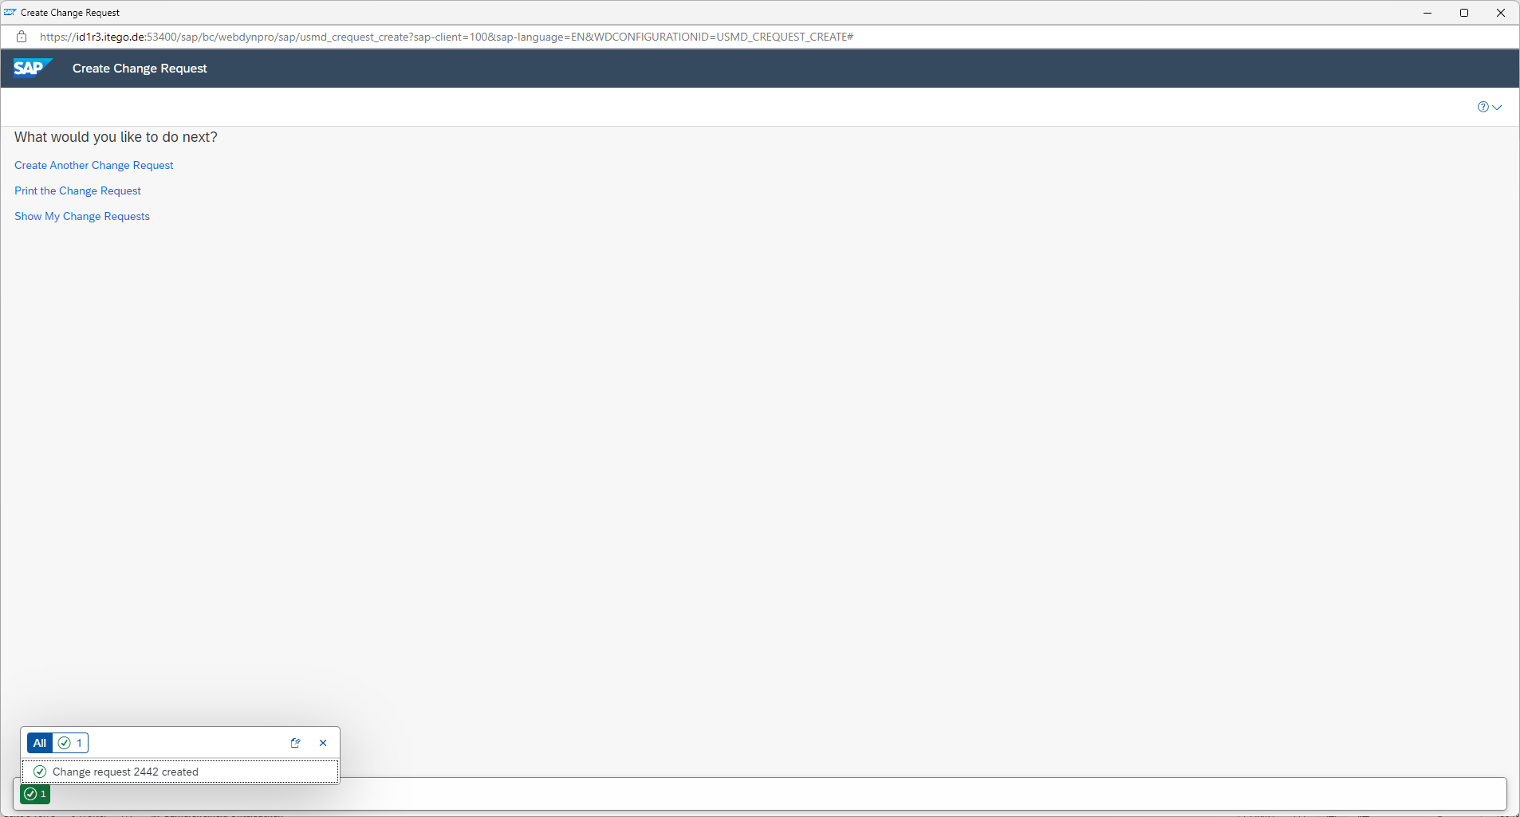
The change request 2442 was created with all objects that have been entered during the creation process. The objects in the change request that have been created during that process exist as some kind of empty objects until they have been maintained in more details.
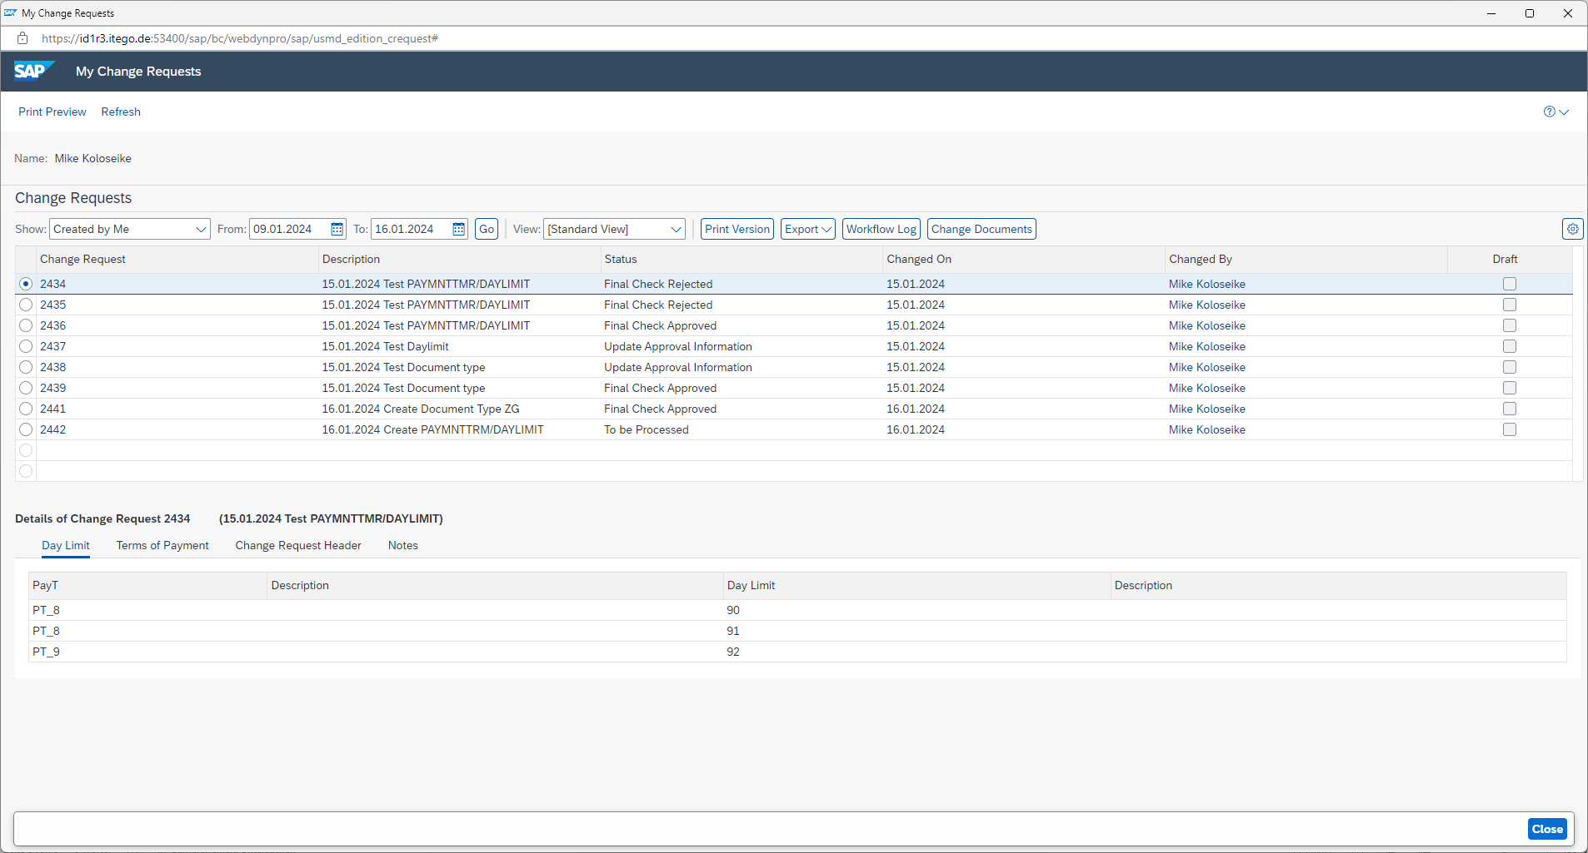
Select change request 2442 to maintain the objects within the change request itself.

In the general overview of the change request choose the tab „Changes“ to maintain the objects of the change request.
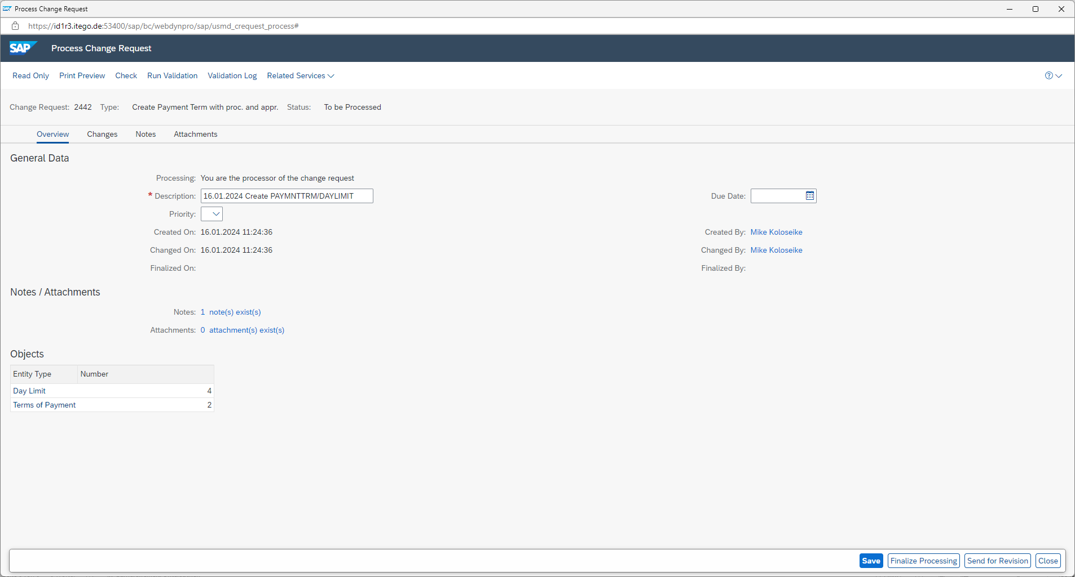
Show Objects of Entity Type is currently set to „Terms of Payment“. The list below contains the new created Terms of Payment and can now be changed via selecting one of the Payment Terms and clicking on „Single Processing“.
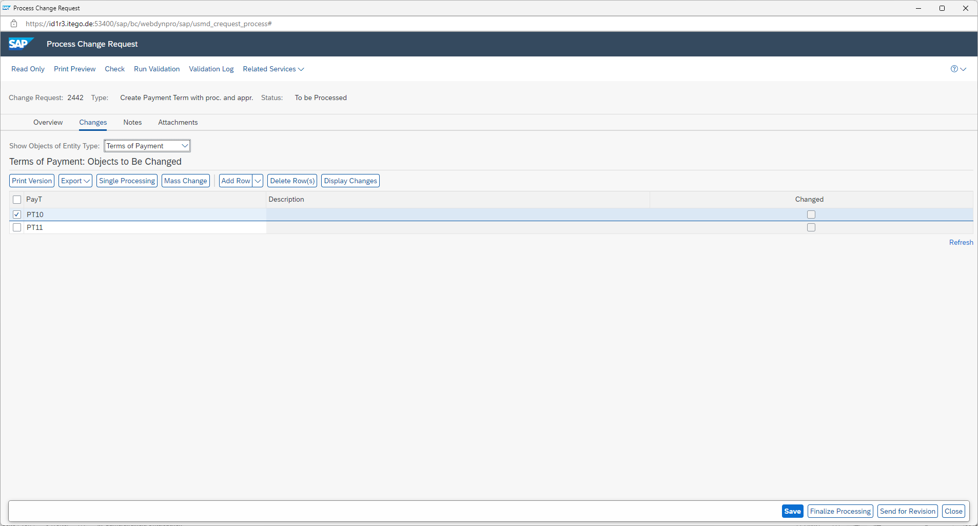

The maintenance for each object in the change request needs to be done specifically for each object. Following the maintenance of Payment Term PT10.
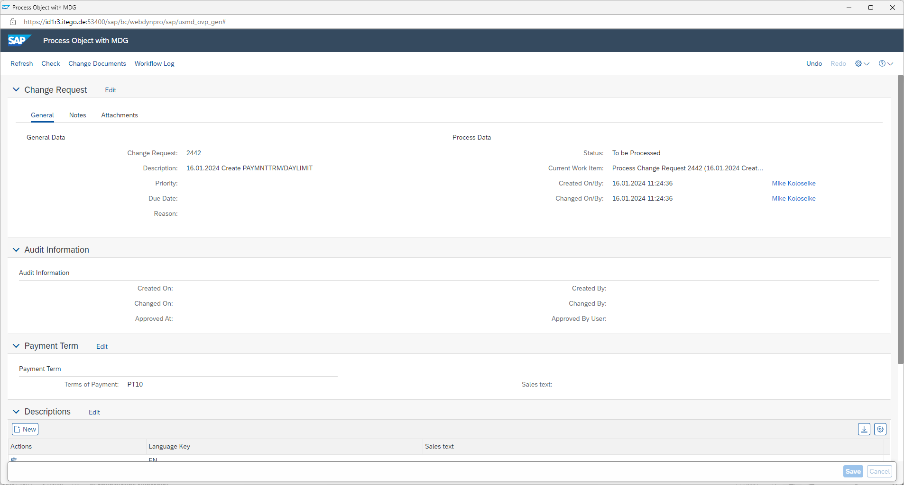
Saving of Payment Term PT10 with enriched details
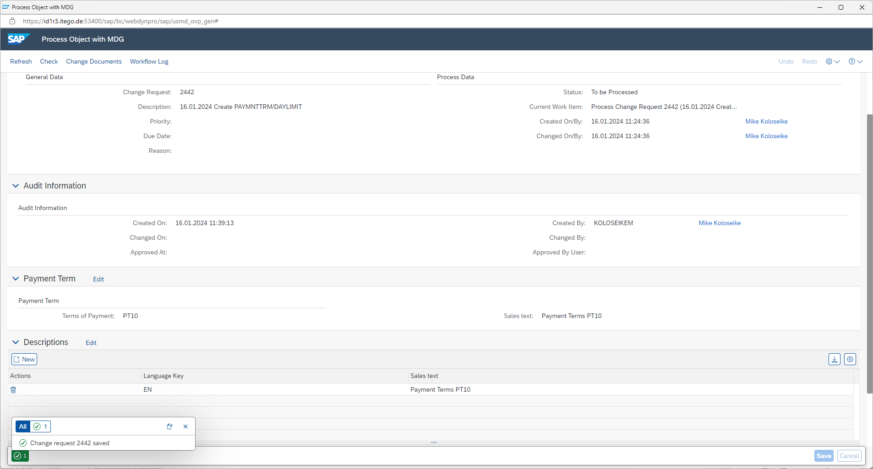

Maintenance of Payment Term PT11
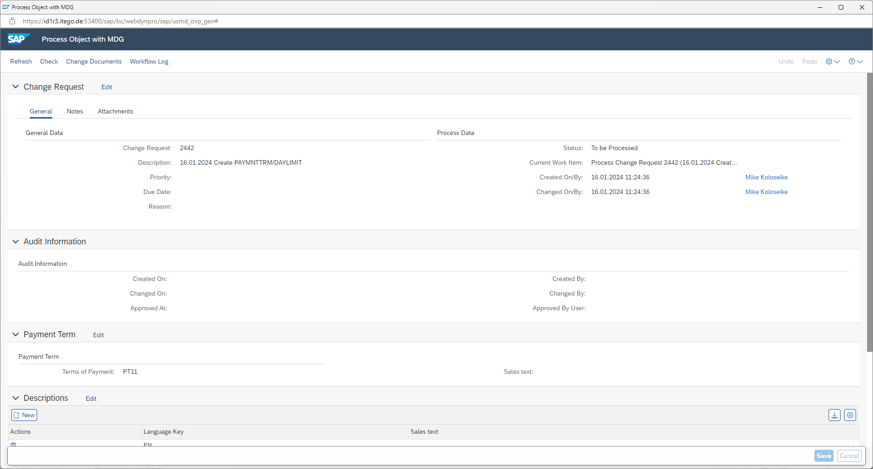
Saving of Payment Term PT11 with enriched details
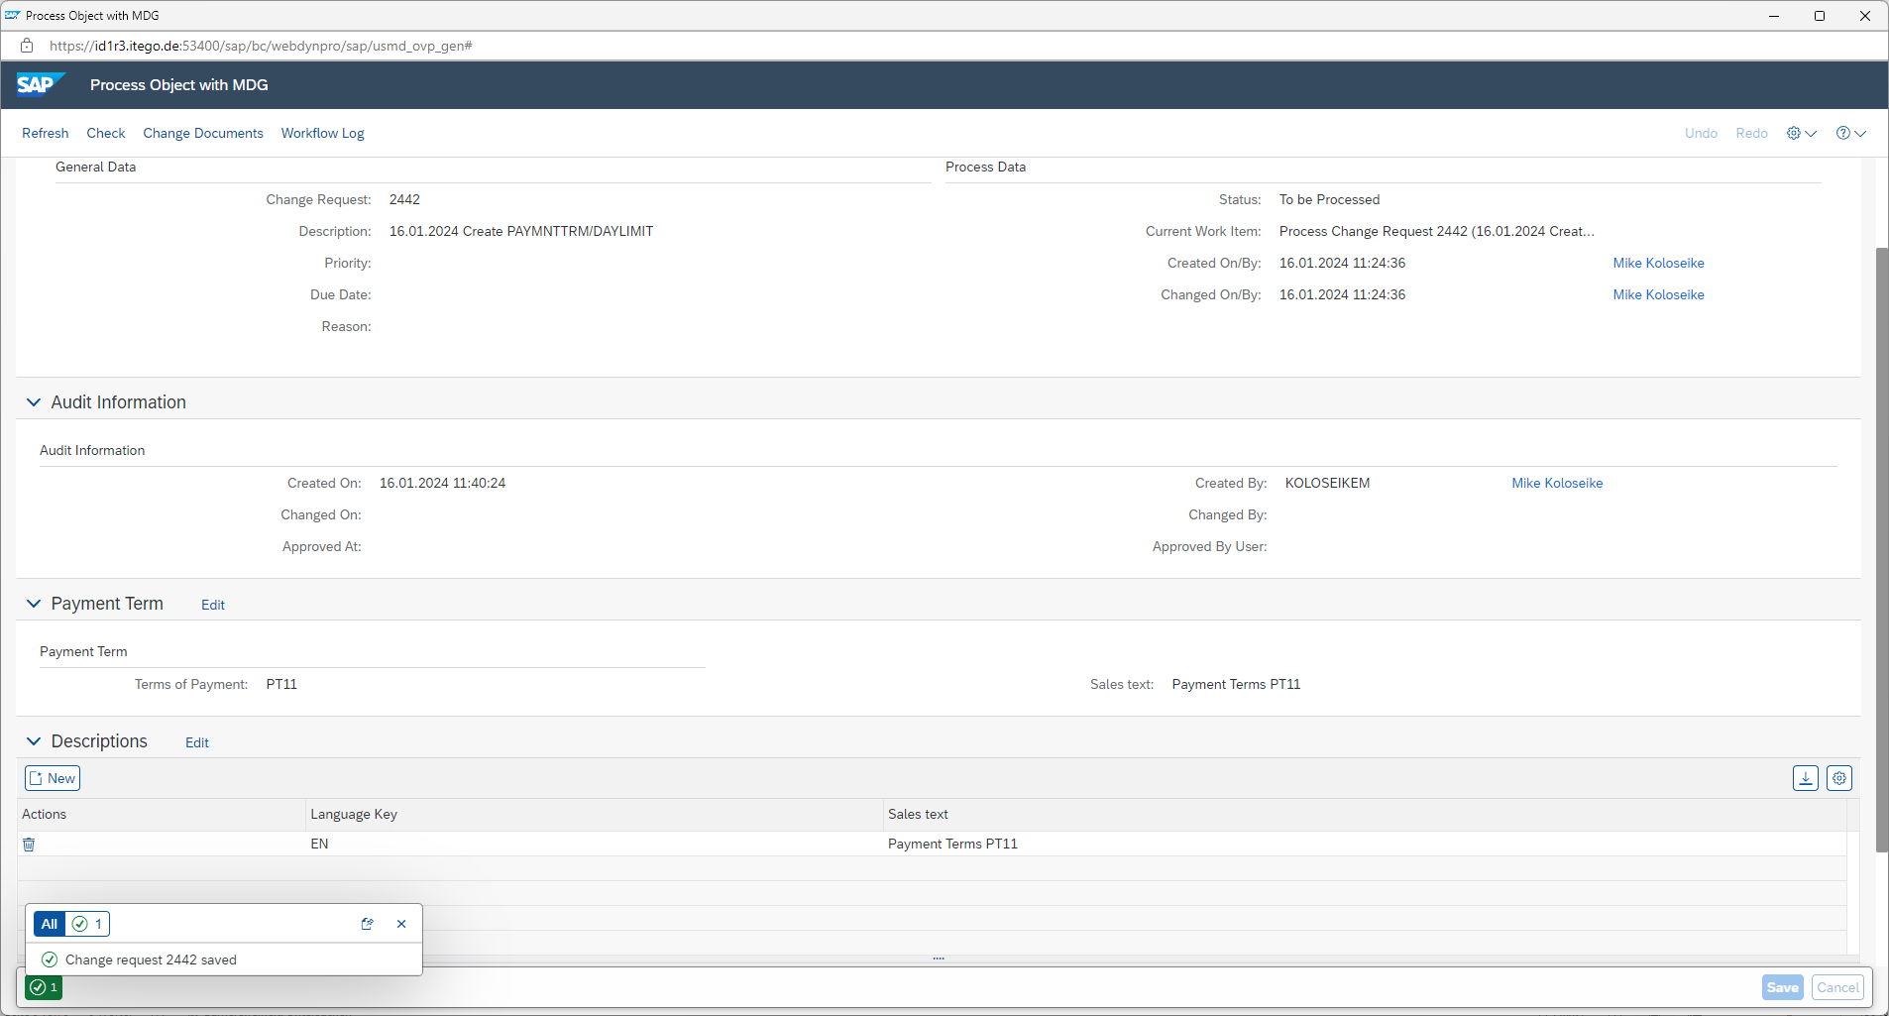

After the maintenance of all Payment Terms itself, the view can be switched to Day Limit as the shown object, which enables you to maintain the Day Limits. Select one Day Limit and click on „Single Processing“
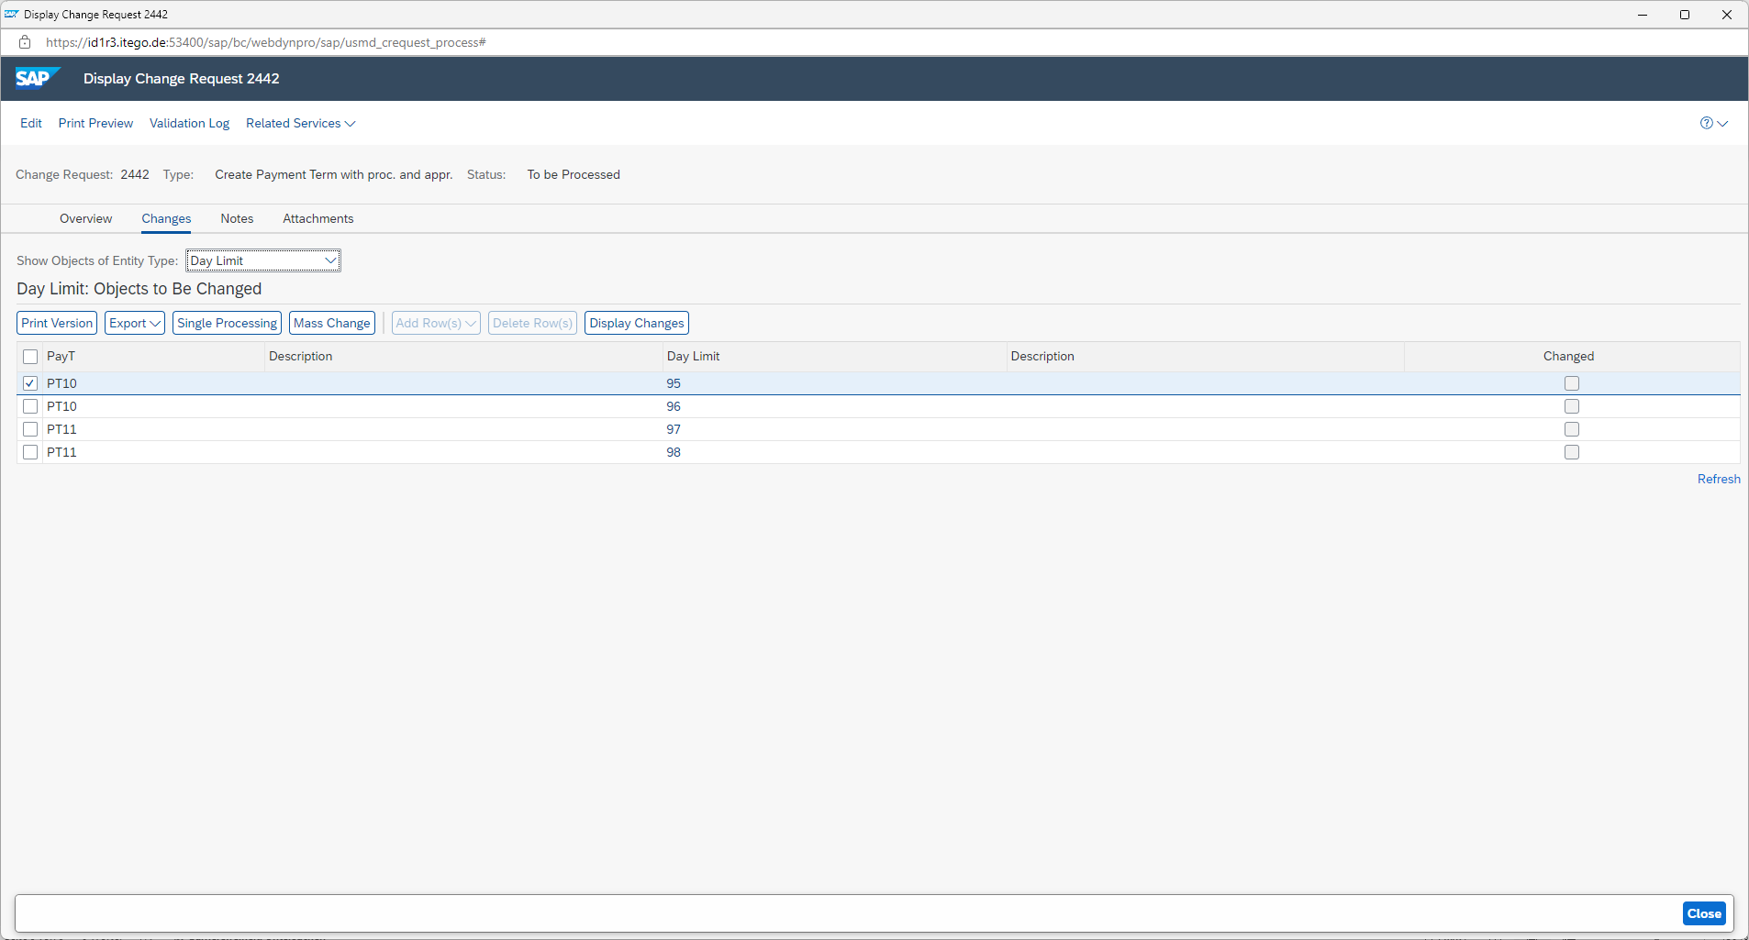
Maintenance of Day Limit 95
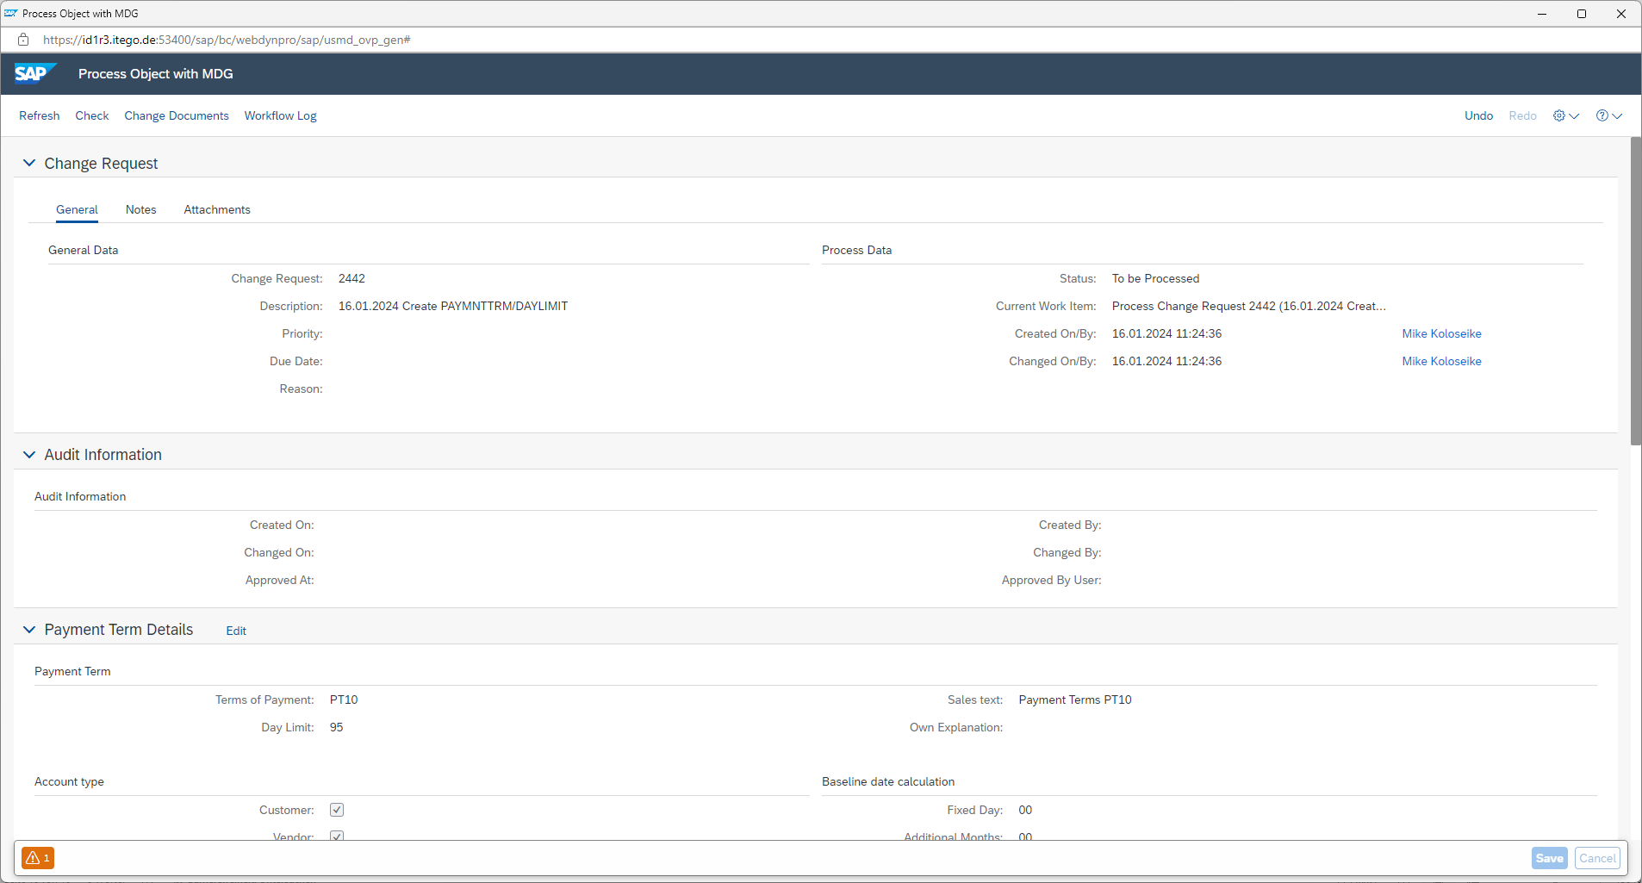
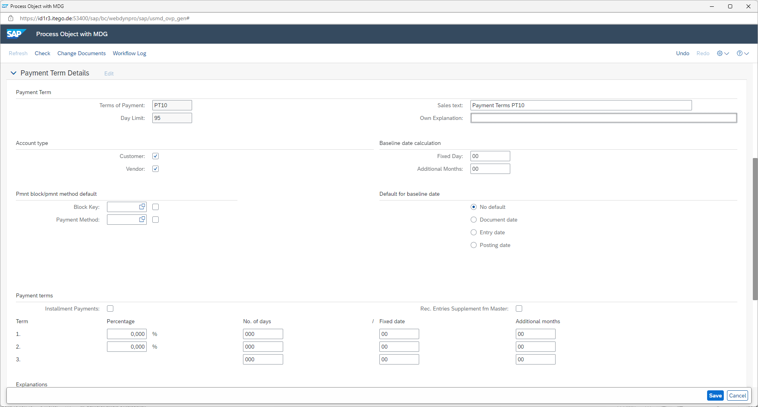
Saving of Day Limit 95 with enriched details
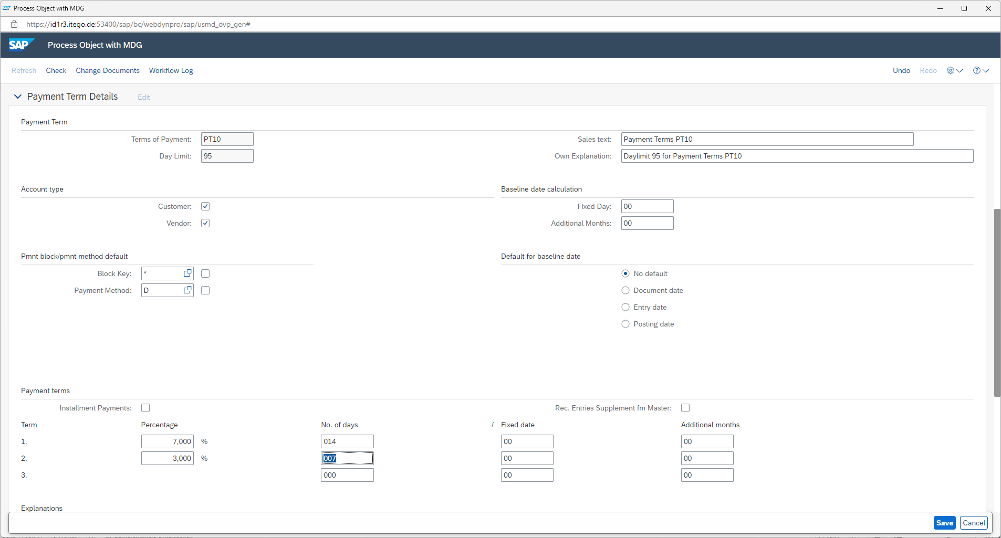

Select the next Day Limit that should be maintained and click on „Single Processing“
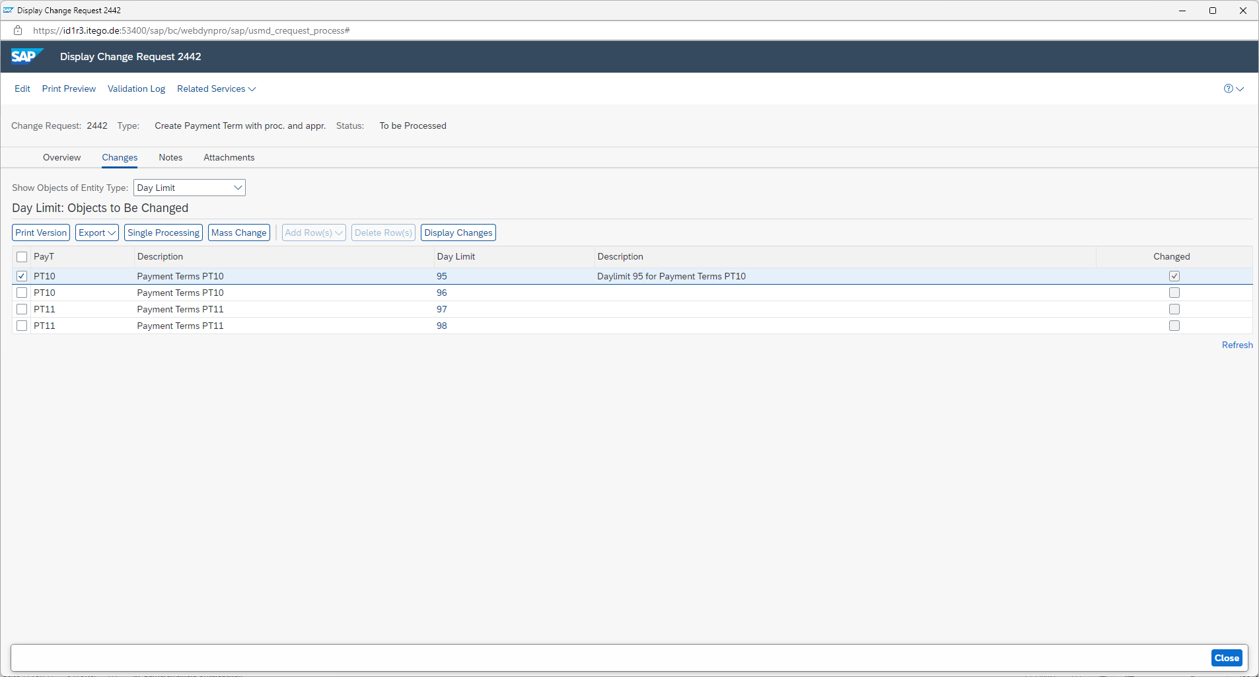
Maintenance of Day Limit 96
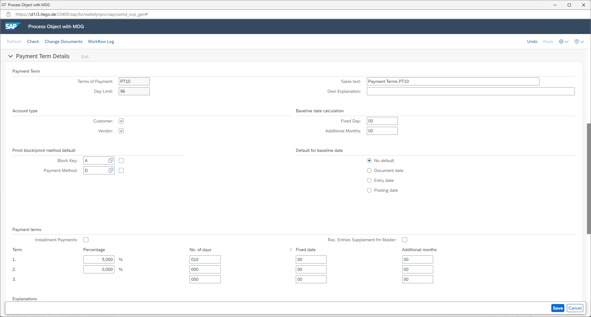

Maintenance of Day Limit 97
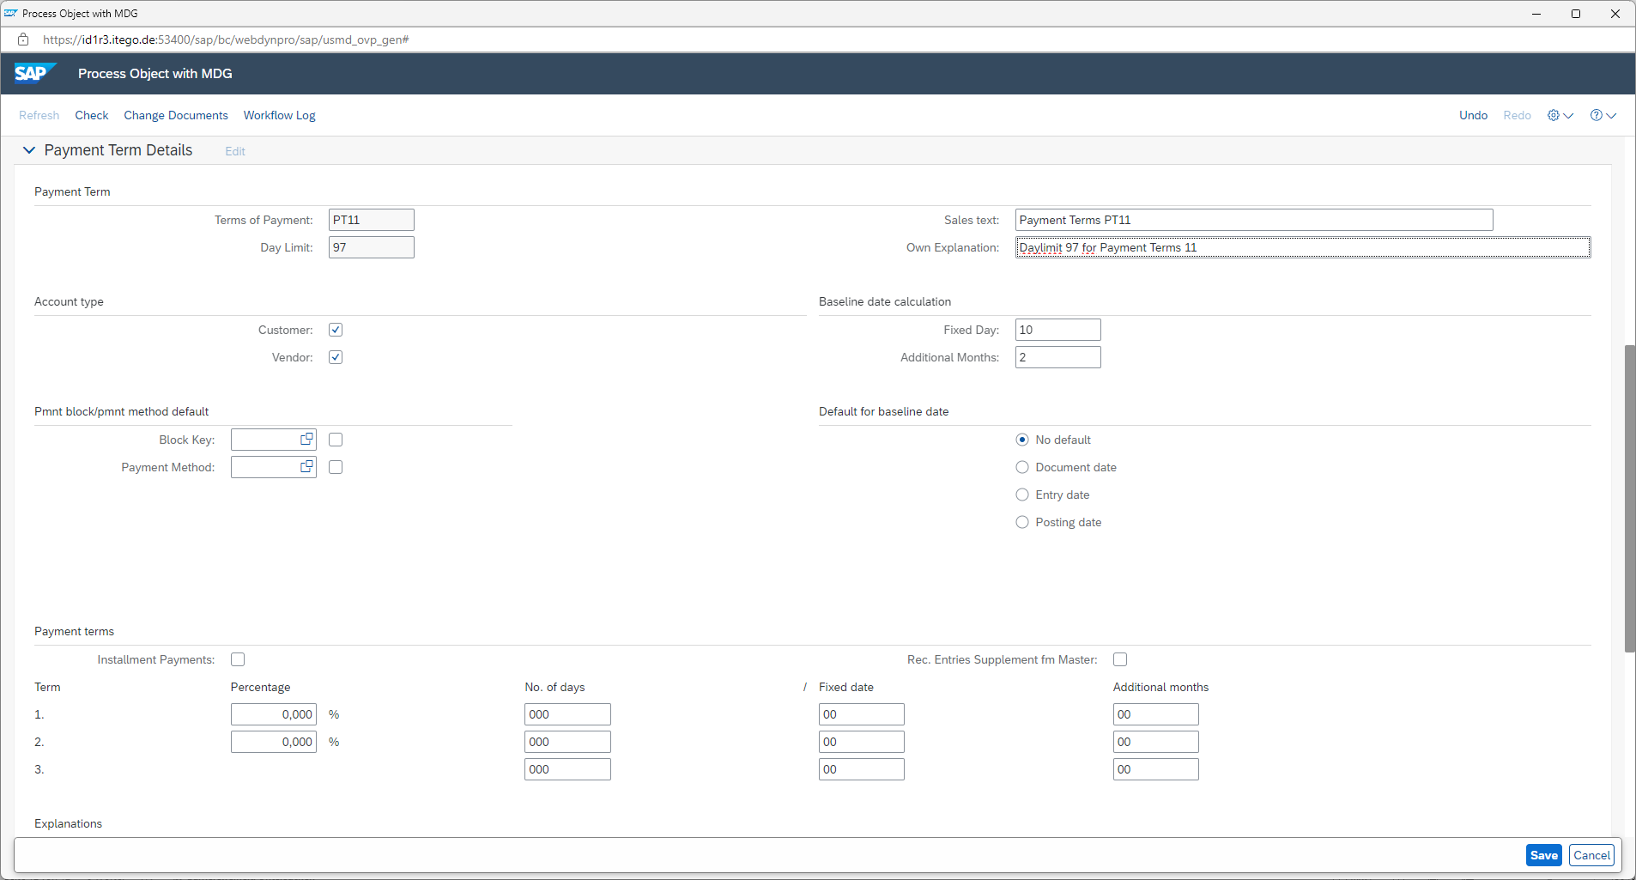
Pressing the „Refresh“ link in the bottom right of the screen gives the ability to check, which Day Limits have already been maintained and which are still in an unchanged status since creation.
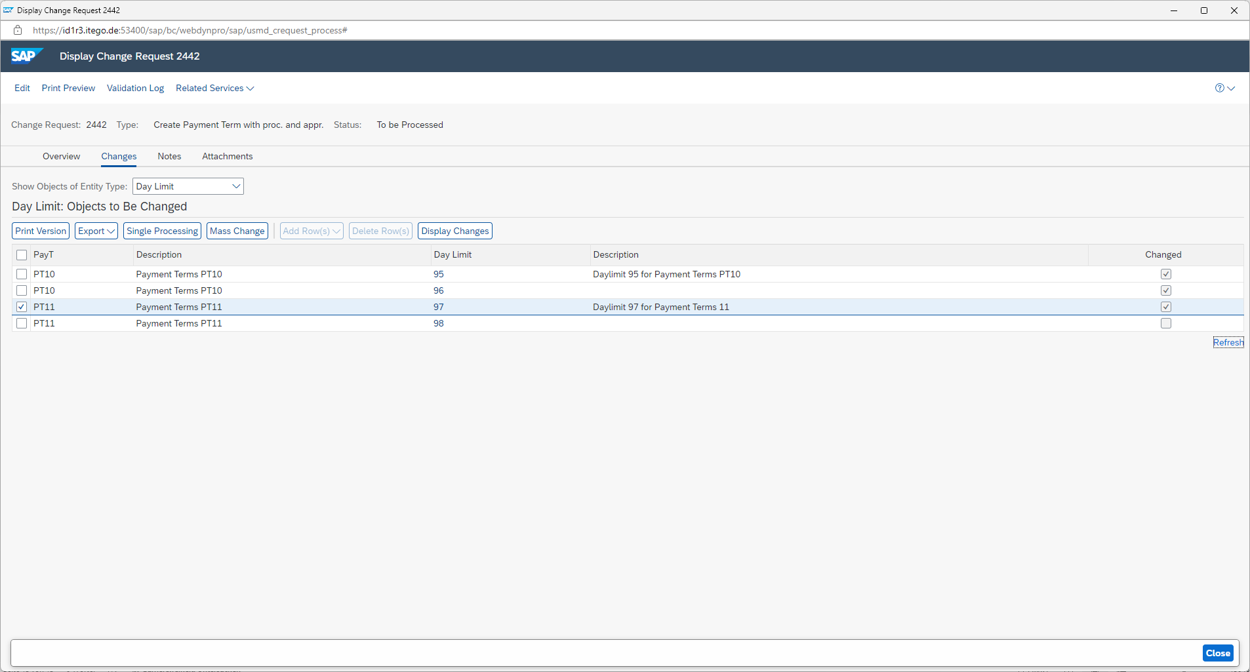

Maintenance of Day Limit 98
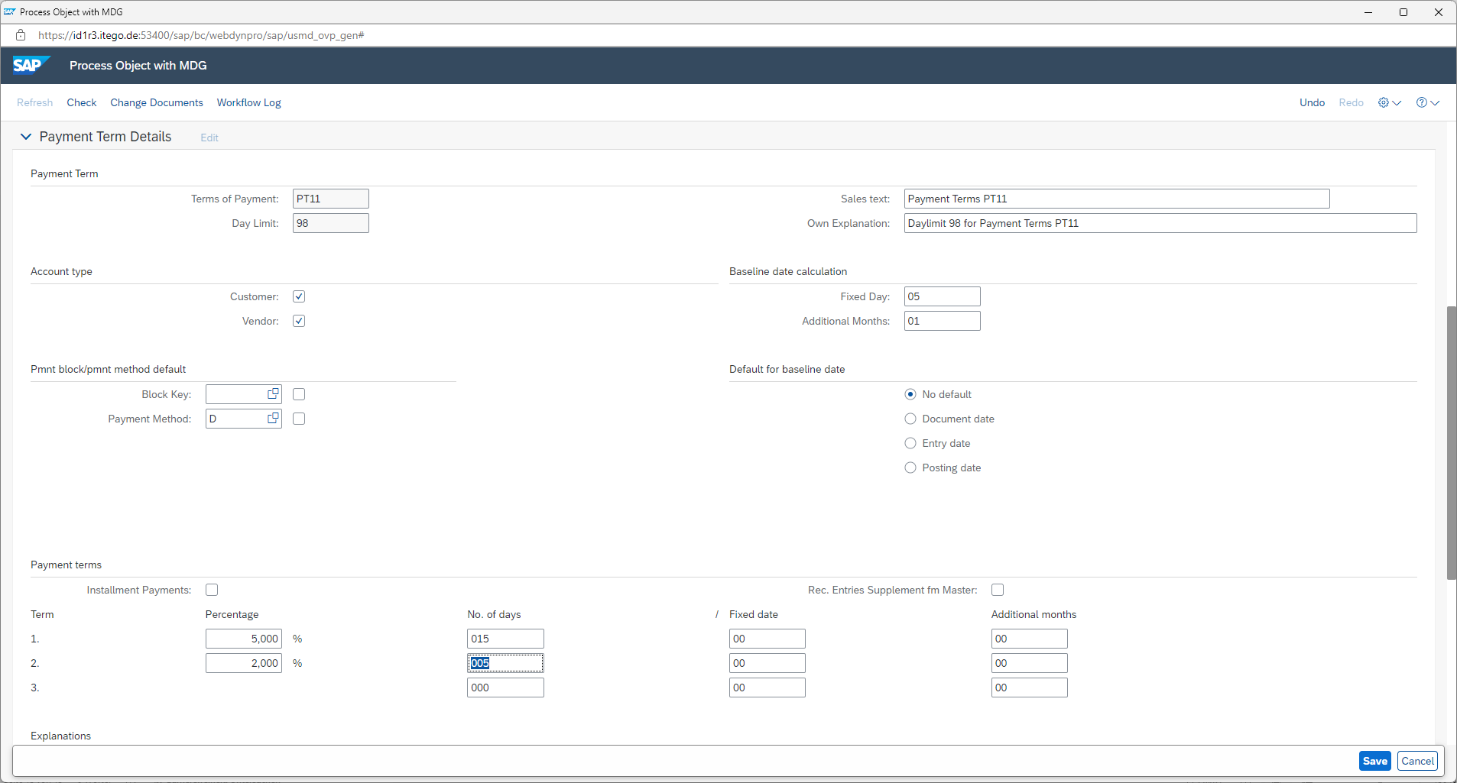
After maintenance of all objects in the change request finish the step by clicking „Finalize Processing“
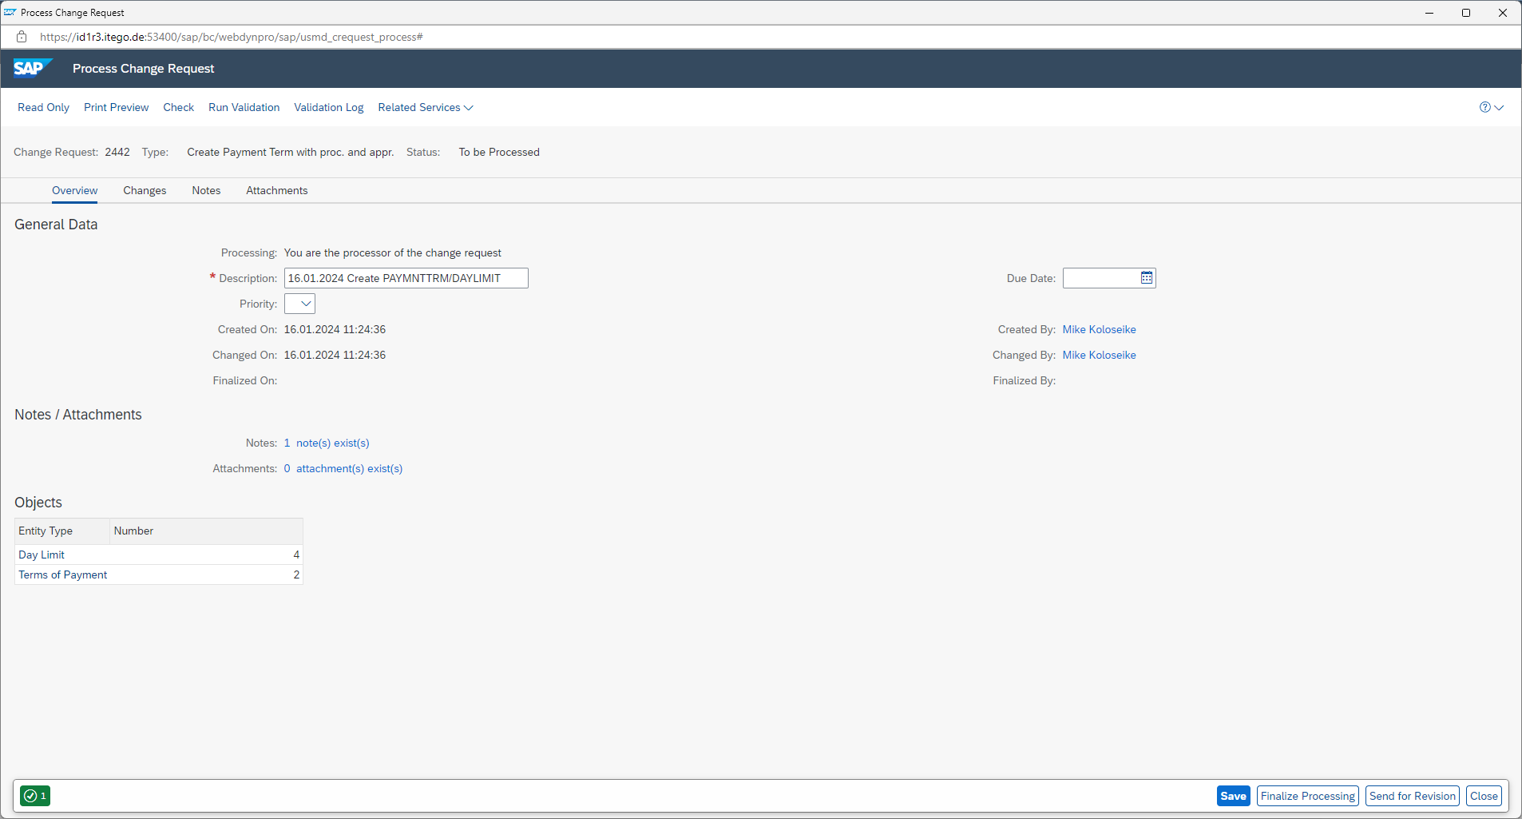

The change request 2442 is now in status „To be approved“ and is waiting for the final approval
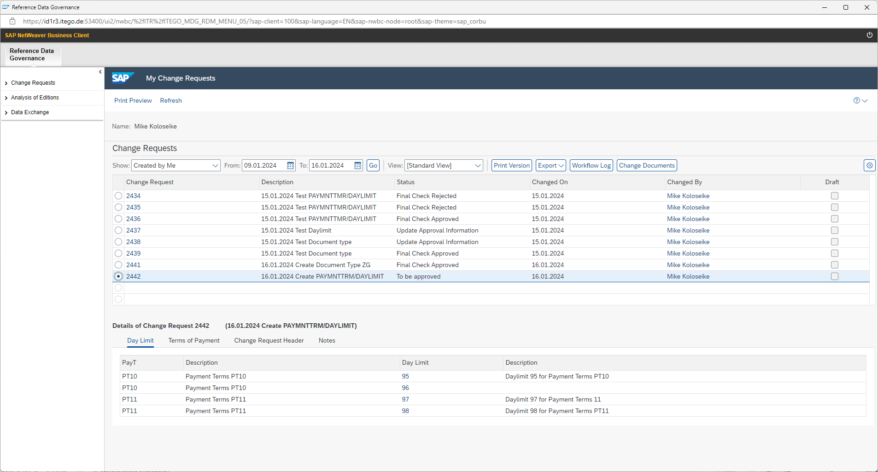
Reopening the change request gives the ability to finally „Approve“ the change request
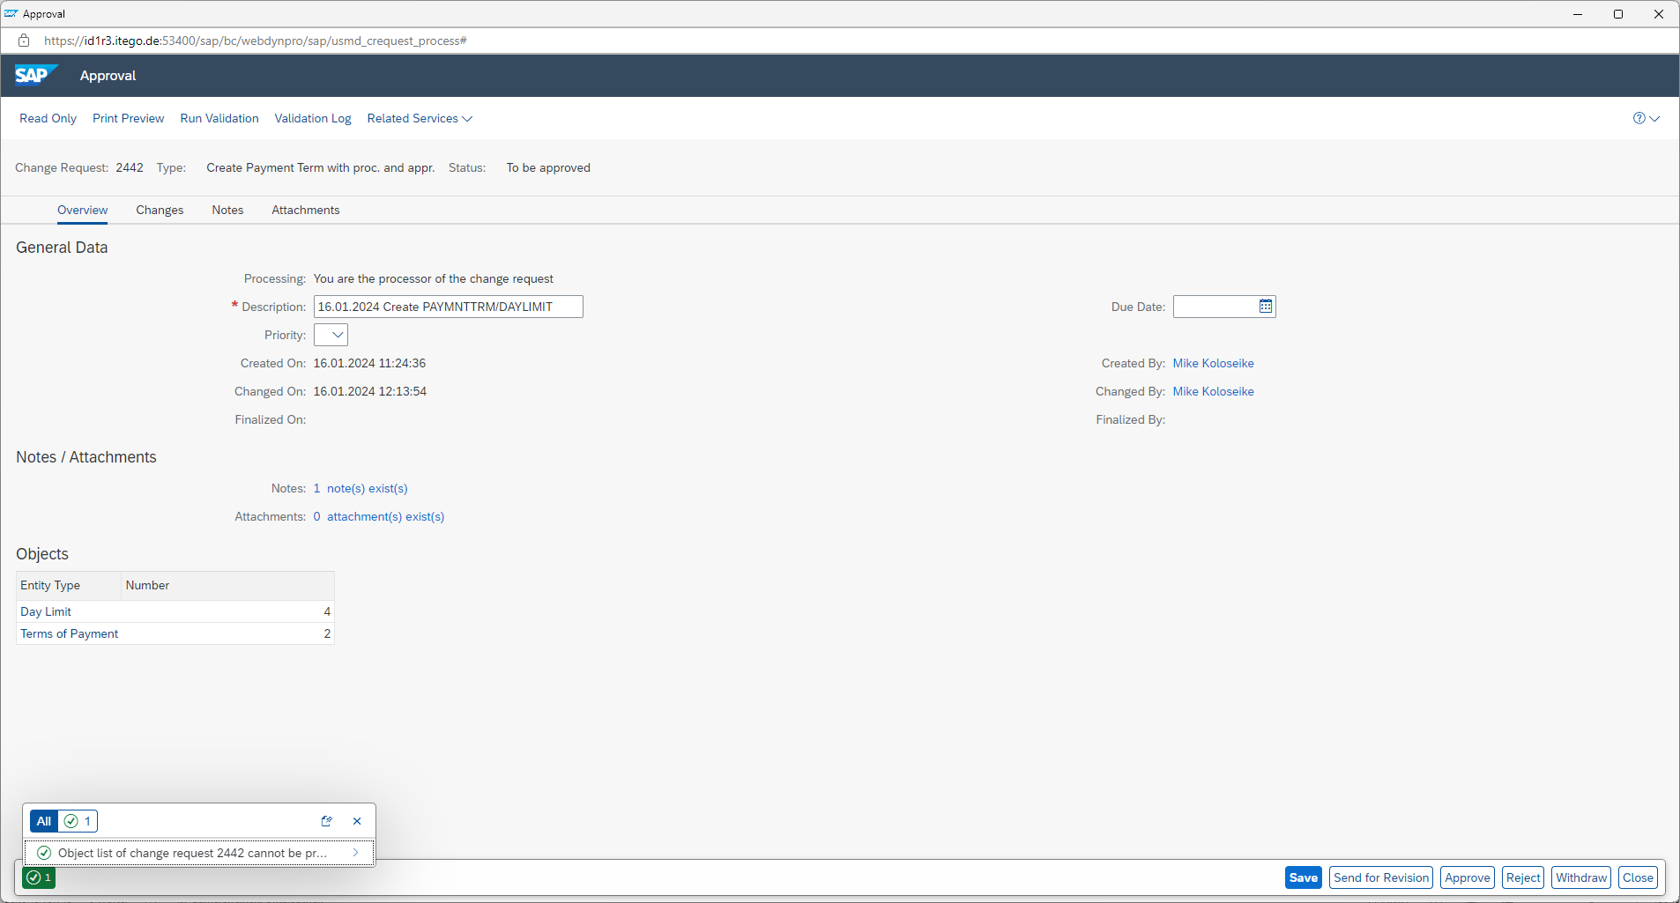
Clicking on „Approve“ finalizes the process as a whole

After the change request has been approved the objects will be replicated to relevant and customized systems as part of the normal RDM process
